WINDER MOTOR

Different types
Type of bearings
Function and application
Setting up
Methods and types of lubrication
INTRODUCTION

Modern winders make use of AC and DC motors as a source of power. In some instances through large reduction gearing as in the case of AC motors, and through direct drives as in the case of DC motors. AC motors are primarily fast-rotating motors; the gearbox reduces the speed and increases the torque from the motor to the drum shaft.
Due to the amount of energy these motors produce, they are subject to overheating. Many ingenious controls and cooling systems have been produced to combat such overheating, and therefore require an equal amount of ingenuity in fault finding and maintenance.

In this module the following will be discussed:

Different types and method of mechanical connections
Type of bearings fitted to motors
Function and application of bearings
Setting-up and lining-up of motor bearings
Koepe winder motors
Methods and types of lubrication
Oil ring lubrication – hand filled
Flooded or header tank lubrication
Cooling systems
Open circuit
Closed circuit

DIFFERENT TYPES AND METHOD OF MECHANICAL CONNECTIONS

AC motors are normally fast-rotating. These motors are normally employed to drive a winder through a reduction gearbox.
The mechanical connection between motor and gearbox is by means of a flexible coupling as illustrated in Fig. 1.

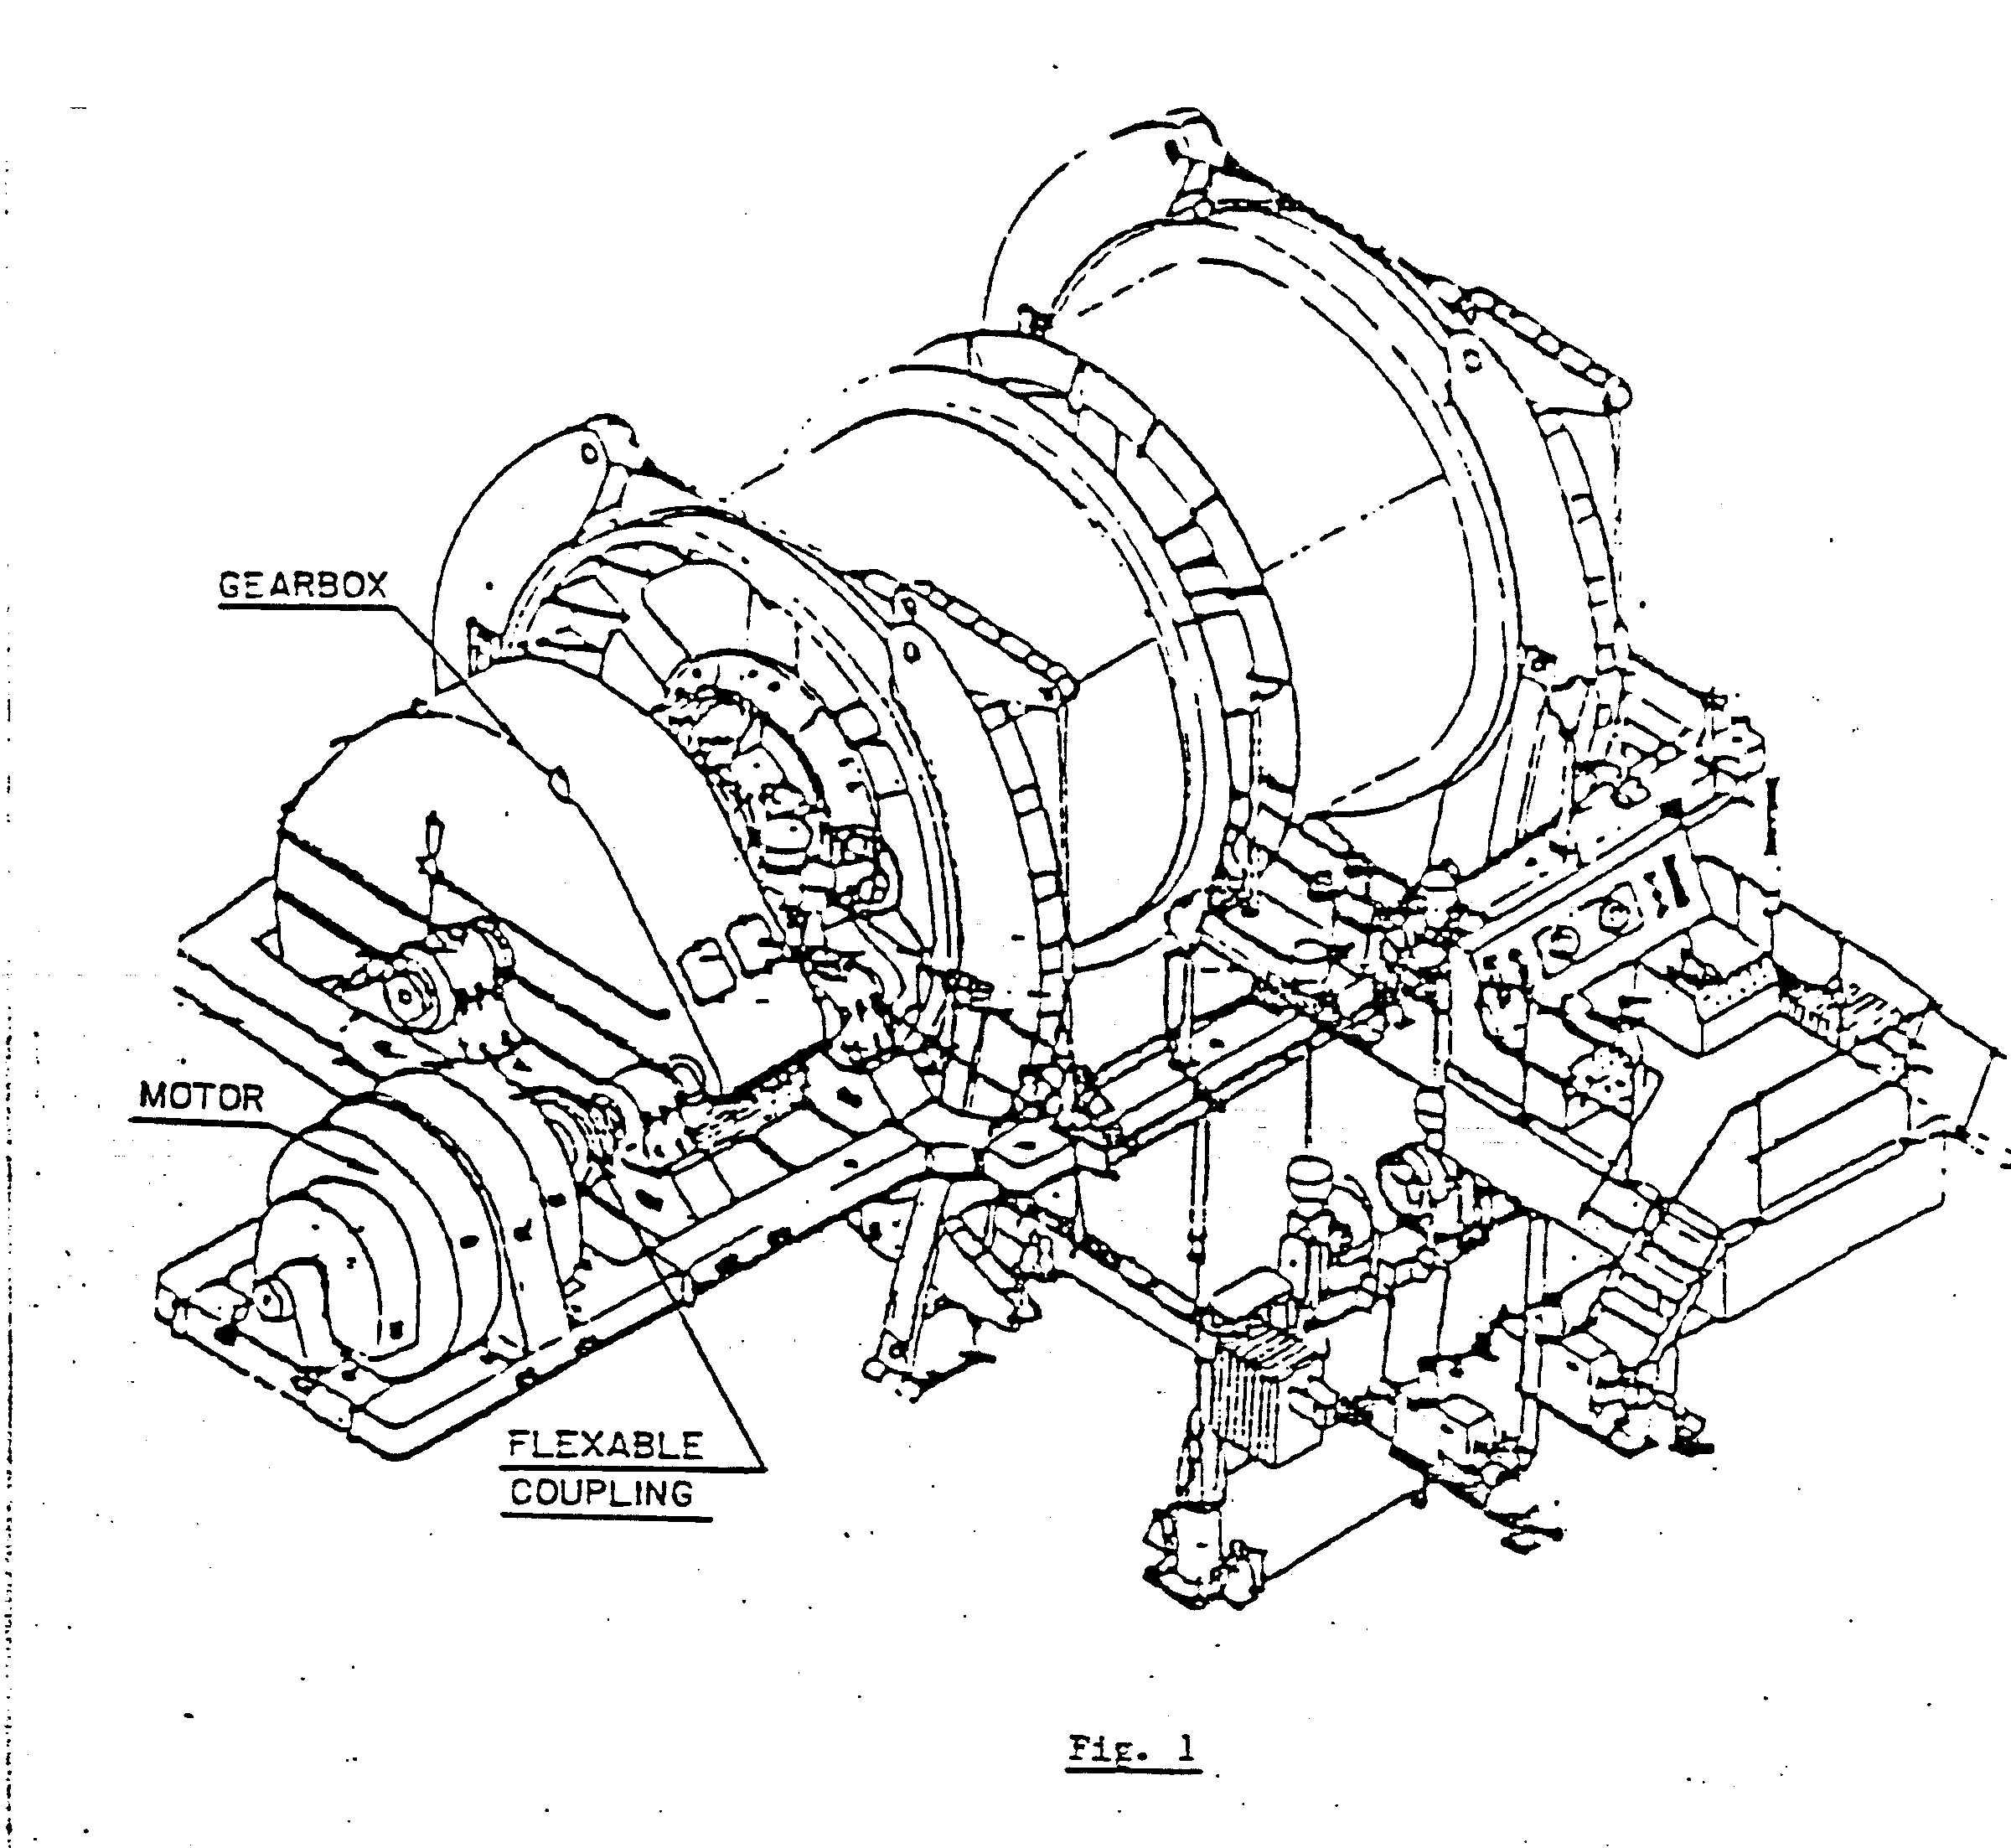
Fig. 2 illustrates two motors driving a winder through a reduction gearbox. The mechanical connections are by means of flexible couplings.

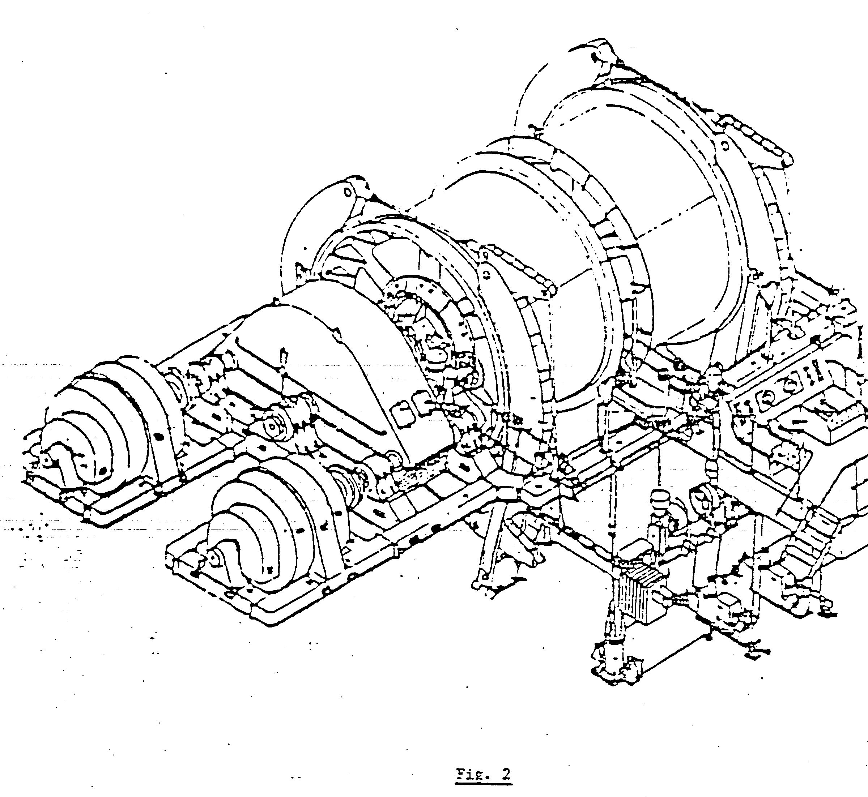
In Fig. 3, a DC motor is coupled directly to the drum shaft and not through a gearbox. These DC motors are normally employed without bearings; however, older types of DC motor winders do make use of a single bearing at the non-drive end. The rotor is coupled to the end of the drum shaft by means of a rigid coupling.

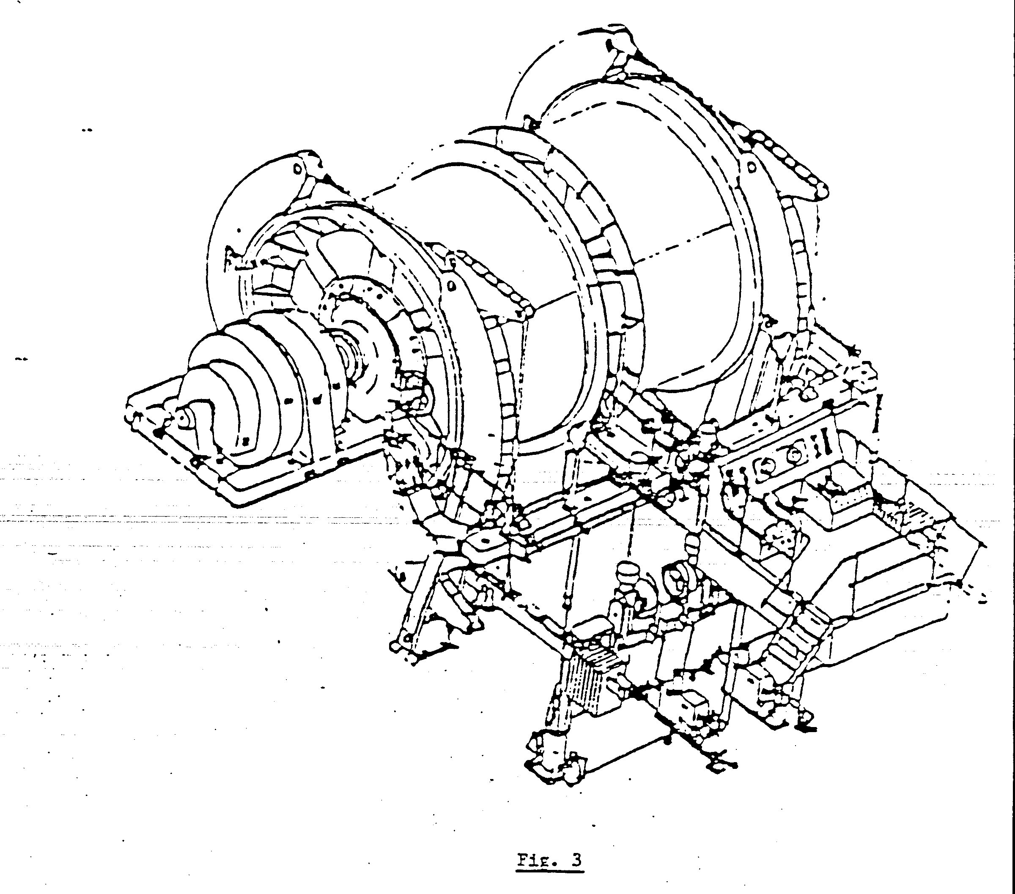
TYPE OF BEARINGS FITTED TO MOTORS

Motor bearings are normally the pedestal-type, fitted with self-aligned bearing shells; white metal lined with a horizontal split.
The bearing housing has an integral sump and must only be filled with recommended oil. Oil rings are employed to lubricate the bearing.
The bearing housings are fitted with lip-type oil seals to exclude dust and prevent leakage of oil. A sight glass is mounted on the bearing to indicate the oil level in the integral sump.
Fig. 4 shows a typical pedestal-type motor bearing.
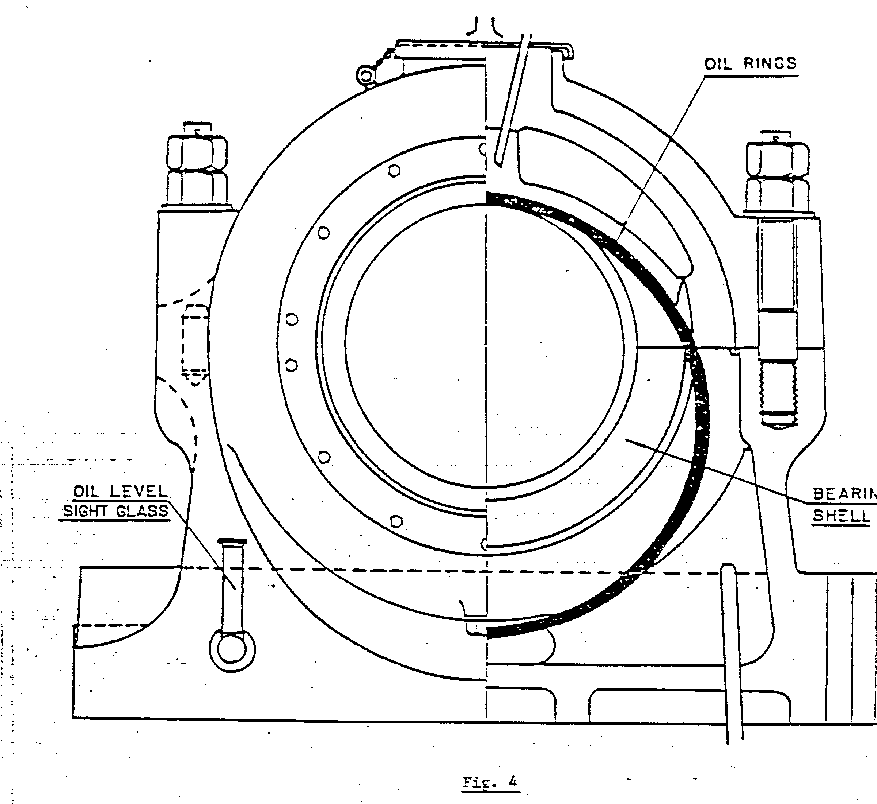

FUNCTION AND APPLICATION OF BEARINGS

The function and application of a bearing is to support any rotating shaft or apparatus with the least possible friction.

METHODS AND TYPES OF LUBRICATION

Large winder motors make us of pedestal-type bearings with an integral sump. These bearings are lubricated by one of the following systems:

(1) Oil ring lubrication – hand filled
(2) Flooded or header tank lubrication

OIL RING LUBRICATION – HAND FILLED

The bearing is fitted with two split oil rings, which turn with the rotating shaft, drawing the oil out of the sump onto the shaft and bearing.
An oil sight glass is fitted to the bearing housing to indicate the oil level. This oil level must be maintained at all times and checked daily. It is most important to check that the oil rings are rotating freely at all speeds.

FLOODED OR HEADER TANK LUBRICATION

Bearings with circulating oil lubrication can be supplied by two methods – flooded lubrication or the header tank system. In both lubrication systems the return oil pipe in the bearing housing must be so installed that the oil level in the integral sump must be maintained at all times.
In addition, in both lubricating systems oil rings are fitted. Should a fault occur with the circulating oil system, the oil ring lubrication system will operate without the danger of a lack of lubrication.
A circulating oil lubrication system is illustrated in Fig. 9.

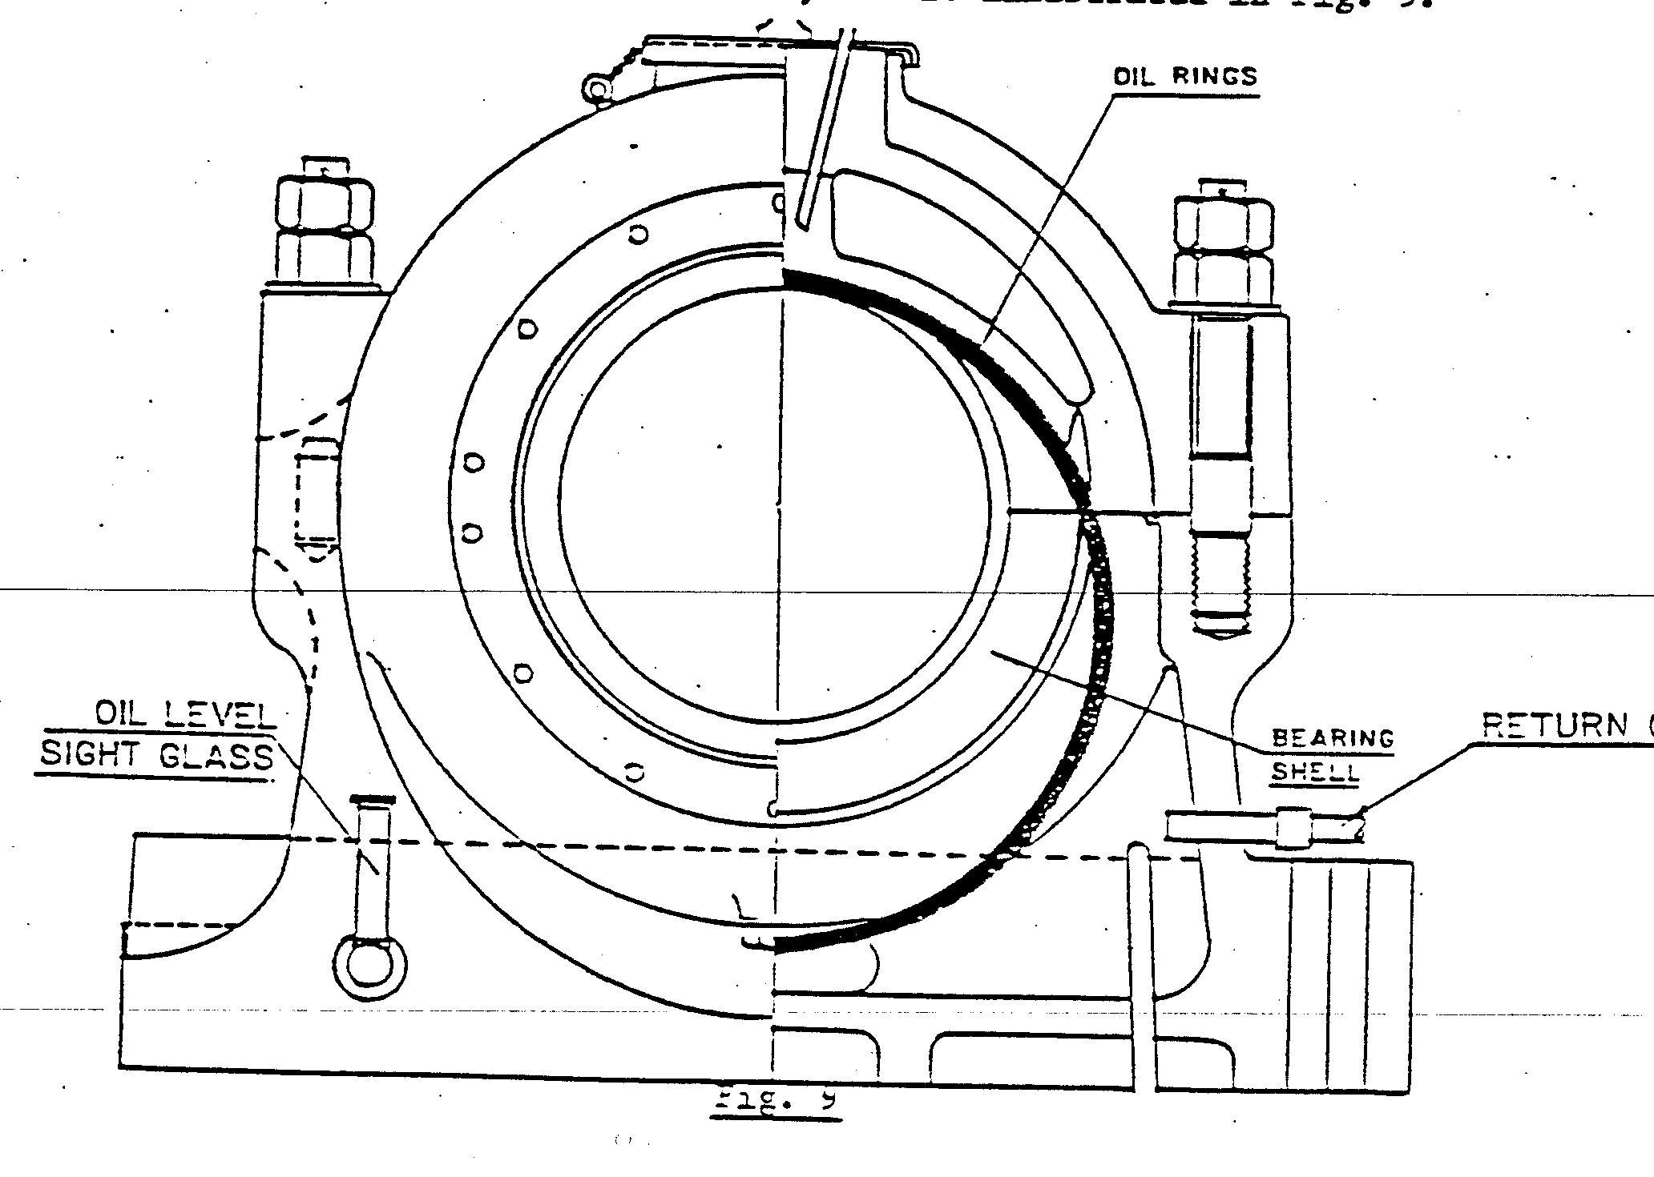
COOLING SYSTEMS

In this section of our module we will deal with the types and locations of cooling fans and the necessary maintenance of these units.

OPEN CIRCUIT

In the case of open-circuit cooling, cold air can either be drawn or blown through a motor. The method described is air being drawn through the motor by means of a centrifugal fan, shown in Fig. 10.

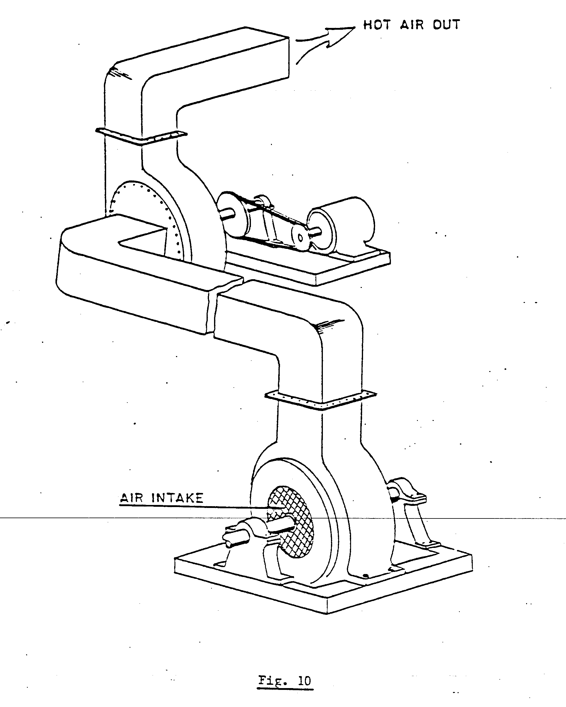
Cold air is drawn from the engine room through the end covers of the motor, passing through the air gap, laminations and windings. The hot air from the winder motor is then drawn through the air ports in the casing of the rotor to the fan, and blown out to the atmosphere.

CLOSED CIRCUIT
A motor-driven centrifugal fan is installed in the basement of the engine room, in an enclosed chamber. This chamber is partitioned to control the air flow shown in Fig. 11.

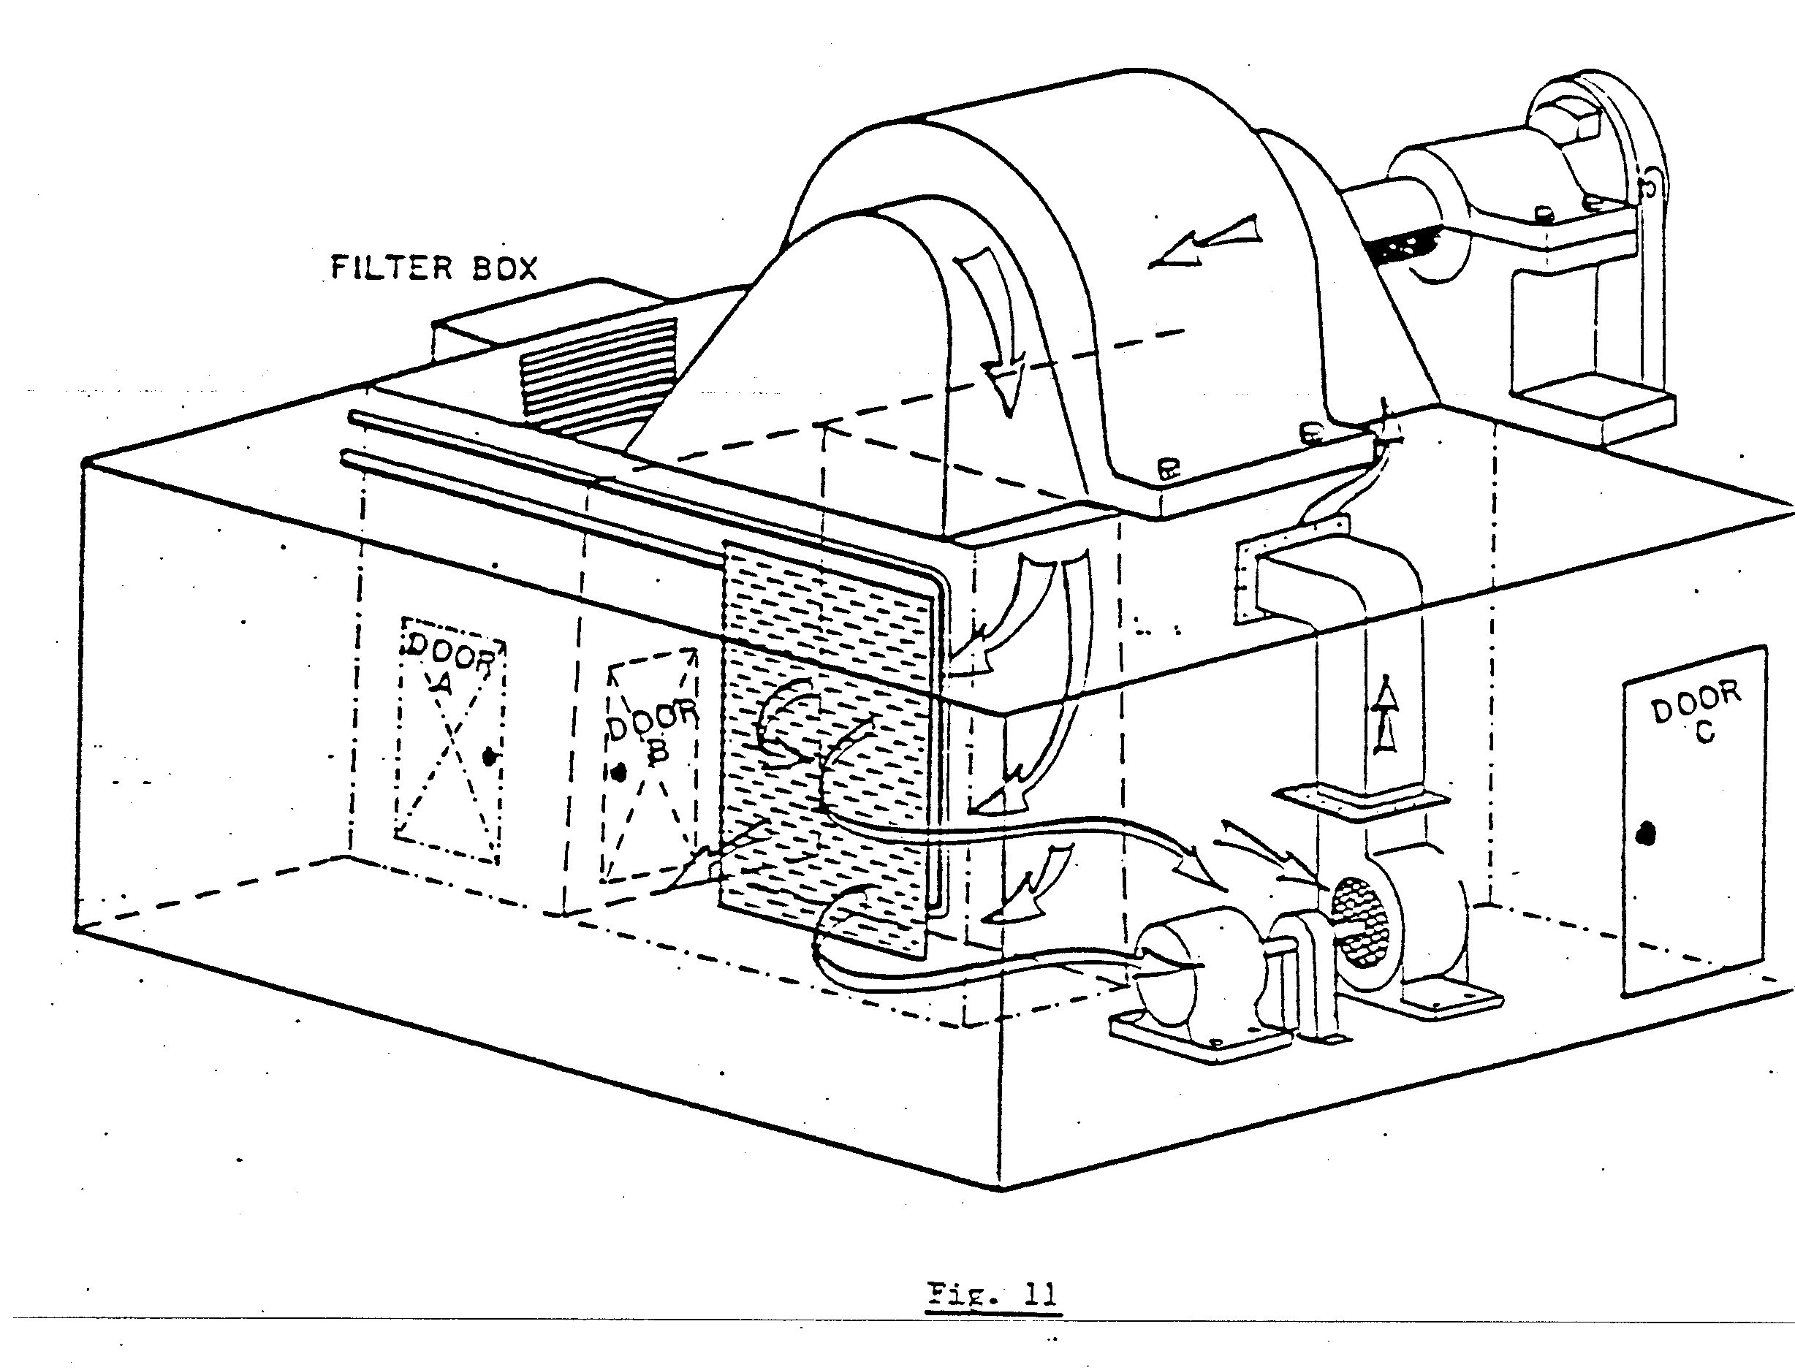
In the closed circuit, the arrows indicate the air flow. The air enters the intake into the motor pit and through the motor. The hot air from the motor flows into the vent pit and through the heat exchanger. The cold air from the heat exchanger is now drawn back to the fan and re-cycled. As the heat exchanger is water-cooled, a flow switch is installed in the inlet side of the water pipe to monitor the water flow. The flow switch is connected into the safety circuit of the winder.
Should a fault occur, a warning alarm will sound indicating not water flow, and the winder will trip at the end of the wind.
A humidity detector is also installed in the intake side of the fan to detect moisture should a leak develop in the heat exchanger.
The humidity detector is also connected into the safety circuit of the winder. Should moist air be detected, a warning alarm will sound and the winder will trip at the end of the wind.

